Photo gallery
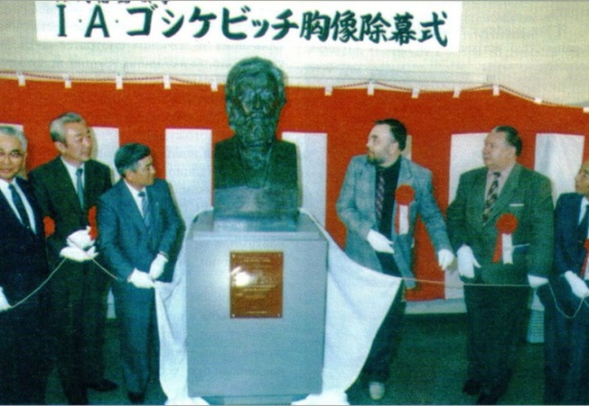
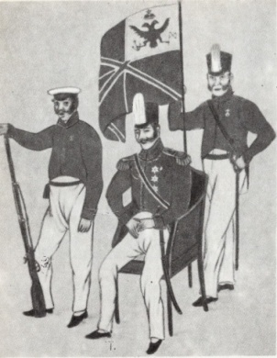
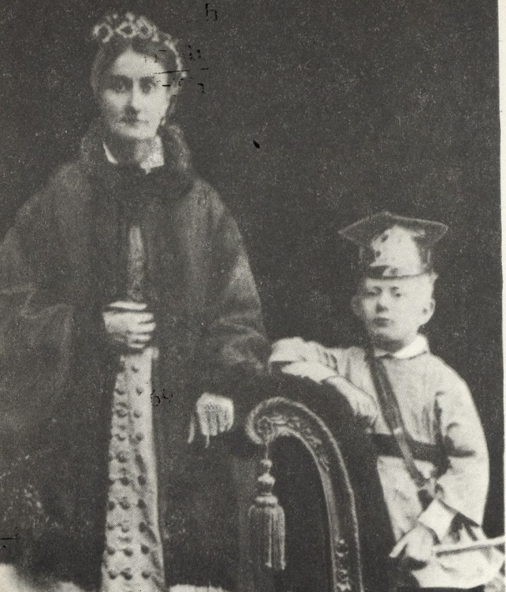  Iosif Goshkevich's wife Ekaterina Semenovna and son Joseph.  Photoof 1875 | 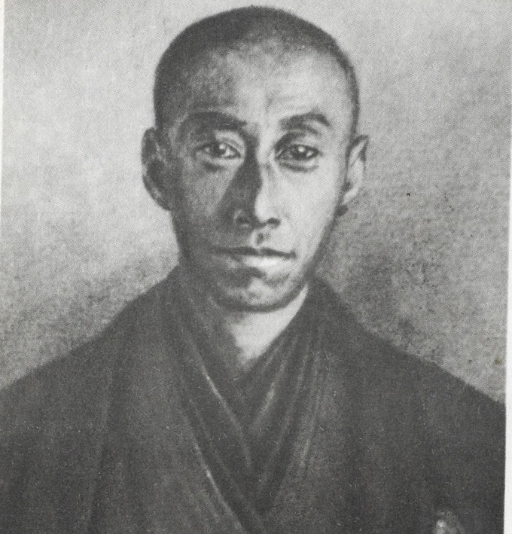  Dr. Tatsibana-no Koos'ai (Vladimir Pribylov). From a drawing by A. F. Mozhaisky, lieutenant of the frigate "Diana". 1854
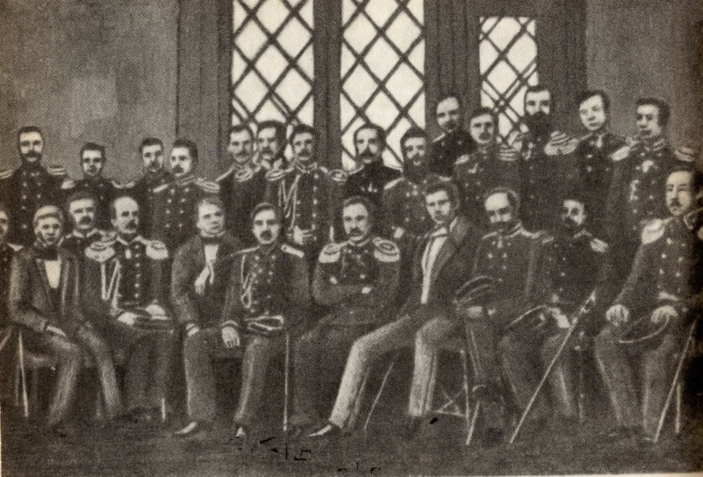
October 1852 I.Goshkevich is the first from the left, next to him the commander of the frigate
I. S. Unkovsky, I. A. Goncharov and Vice Admiral E. V. Putyatin among the officers of the frigate Pallada.
Japanese watercolor depicting the Russian Embassy in 1853 | Opening of the bronze bust of I.Goshkevich in the Museum of the Japanese city of Hakodate

