Books written about Joseph Goshkevich
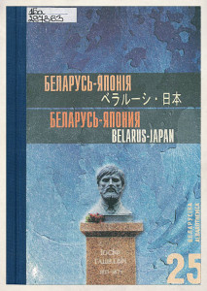 | Belarus-Japan  Materials of the second international readings dedicated to the memory of Joseph Goshkevich, Minsk-Astravets, October 9-10, 2002.  The collection contains materials of the II International Readings dedicated to the memory of Gashkevich. In addition to articles devoted to his life path, the topics of the interrelationships of Belarus, Russia and Japan, the history and modernity of a part of his homeland — the Ostrovets Region, as well as the country that Joseph Goshkevich devoted many years of his life to studying - Japan. | 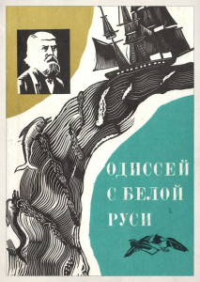 | Odyssey from White Russia  The book "Odyssey from White Russia" is a historical novel by Vitaly Grigoryevich Guzanov, dedicated to the life path of Joseph Goshkevich. It covers the period of life that began with Goshkevich's arrival on the frigate Pallada to participate in Putyatin's diplomatic mission to Japan, covering all his travels until his death. This book is interesting not only for those who are interested in history, but also just for those who love adventures.
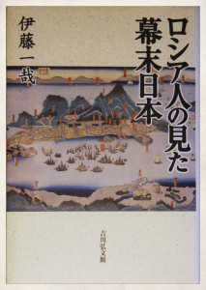 | Kazuya Ito  The author of this book is Japanese researcher Kazuya Ito. It was published by the Chiro Foundation Publishing House. It is written in Japanese, which, unfortunately, complicates the acquaintance of compatriots with it. Devoted to the study of the life of Joseph Goshkevich. It also includes inclusions from diplomatic documents on the history of Russian-Japanese relations. | 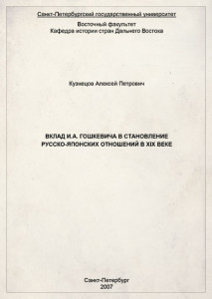 | A.P. Kuznetsov  I.A.Goshkevich's contribution to the formation of Russian-Japanes erelationsin the XIX century  The monograph of the Bachelor of St. Petersburg State University A. P. Kuznetsov describes through the activities of diplomatic relations between Japan and the Russian Empire, starting with the mission with E. V. Putyatin to the first Japanese embassy in Russia in 1873, after his return to his homeland.

