The consulate in Hakodate

According to the Shimoda Treaty of 1855, the Japanese government undertook to provide "places and houses" for the Russian consulate, and according to the Treaty of 1858, the right of permanent residence in the Japanese capital was granted to Russian diplomatic representatives.The first building was the Russian Consulate in Hakodate (now closed). It introduced Hokkaido residents to European architecture.
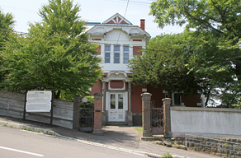  G.Hakodate. The building of the former Russian Consulate. The main entrance. | 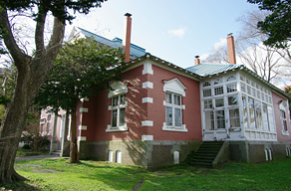  G.Hakodate. The building of the former Russian Consulate. Garden.
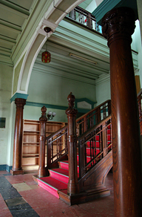  G.Hakodate. The building of the former Russian Consulate. Stairs inside the building | 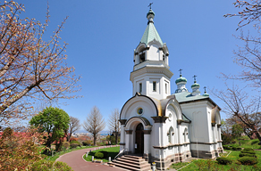  G.Hakodate. Orthodox Church of the Resurrection of Christ.

Hakodate today

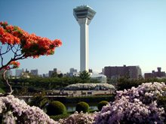 | 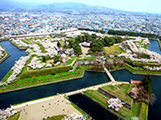 | 