Metrical information about the birth of Joseph Goshkevich
Метрические сведения о рождении
The National Historical Archive of Belarus in Minsk contains metric data that shed light on the date and place of birth of the first consul of the Russian Empire in Japan in 1858-1865, Orthodox missionary, linguist Joseph Gashkevich.
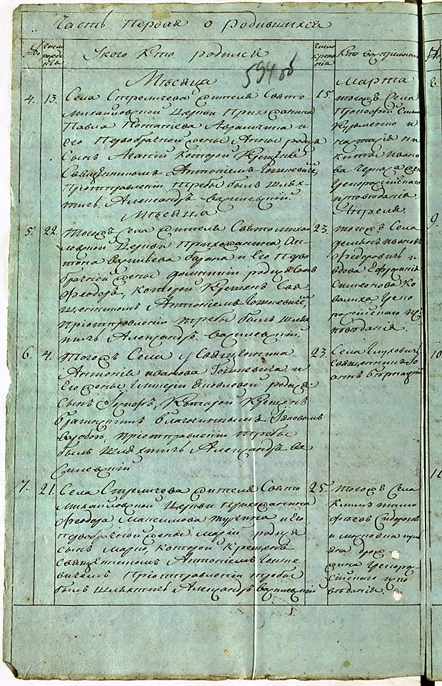
Until that time, there was confusion in all sources with the exact date and place of Goshkevich's birth. Often the exact date was not mentioned at all only a year. But, according to the metric book of the Uniate St. Michael's Church in the village of Strelichev, Rechitsa district, Minsk province (now Khoiniksky district, Gomel region) for 1814, Joseph Gashkevich was born on April 4 (according to the Gregorian calendar – April 16) in the family of a priest of the same church: In the same village [Stralichava], the priest Anthony IvanovGoshkevich and his wife GlikeriaYakovleva had a son, Joseph, who was baptized by the Bragin JacovomVarsoba, when the treba was sent by the nobleman Alexander Vasilevsky." A priest from the village of Glukhovichi, Jan Bernatsky, became the godfather of an outstanding man in the future.

