Monuments to Joseph Goshkevich

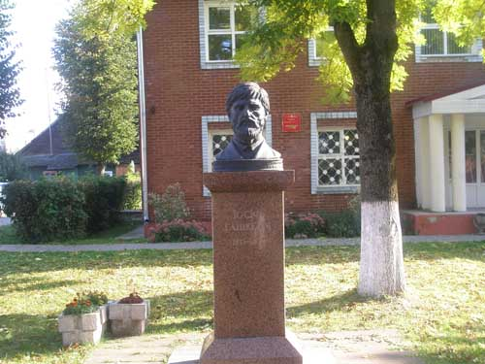 | 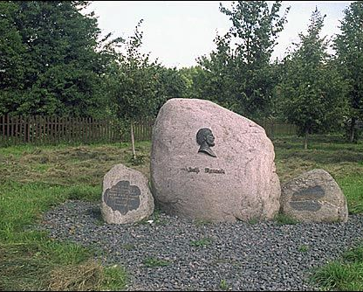 | 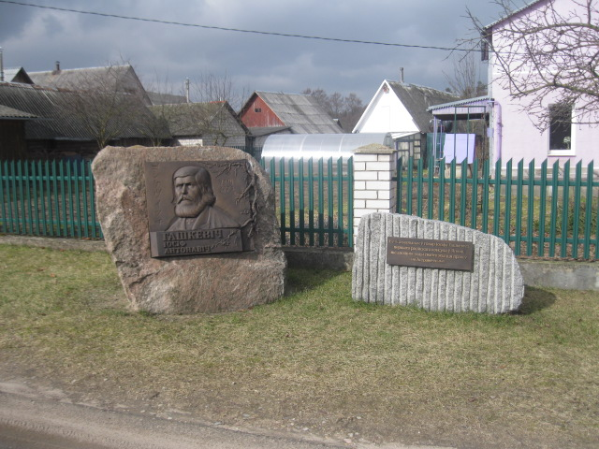
In August 1994, in the center of the urban settlement of Ostrovets, in the presence of the Charge d'affaires of Japan in Belarus Akira Toteyama, a monument to Goshkevich was erected, the author of which is the Belarusian sculptor Valerian Yanushkevich. | In the spring of 2004, a memorial sign by the Belarusian sculptor R. B. Grusha was installed in the village of Mali in honor of a fellow countryman. | On December 29, 2015, a monument to Joseph Goshkevich was opened in the city of Ostrovets, Grodno region. The monument, the author of which is the sculptor Alexander Shumov, was installed on the street of the same name.

