The map of the life of Joseph Goshkevich
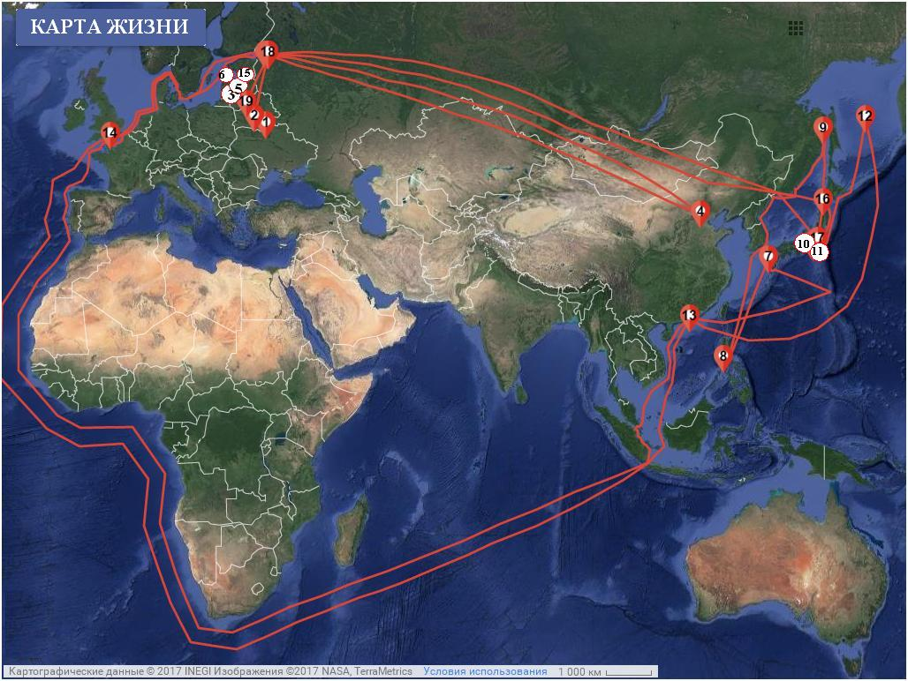
1. Birth. School.
2. Theological Seminary.
3. St. Petersburg Theological Academy.
4. The Chinese period.
5. Work in the Ministry of Foreign Affairs of Russia.
6. The beginning of the mission of the frigate "Pallada"
7. The beginning of the Russian-Japanese negotiations.
8. Inventory of the eastern coast of Primorye.
9. The frigate "Diana".
10. The Simoda Agreement.
11. Head's Bay
12. Captivity (the beginning).
13. Work on the dictionary.
14. Captivity (the end).
15. Appointment as consul in Japan.
16. Diplomatic mission.
17. Meeting with the shogun.
18. Return to St. Petersburg.
19. The last years of his life.

