Record of the death of Joseph GashkevichMay 3, 1875
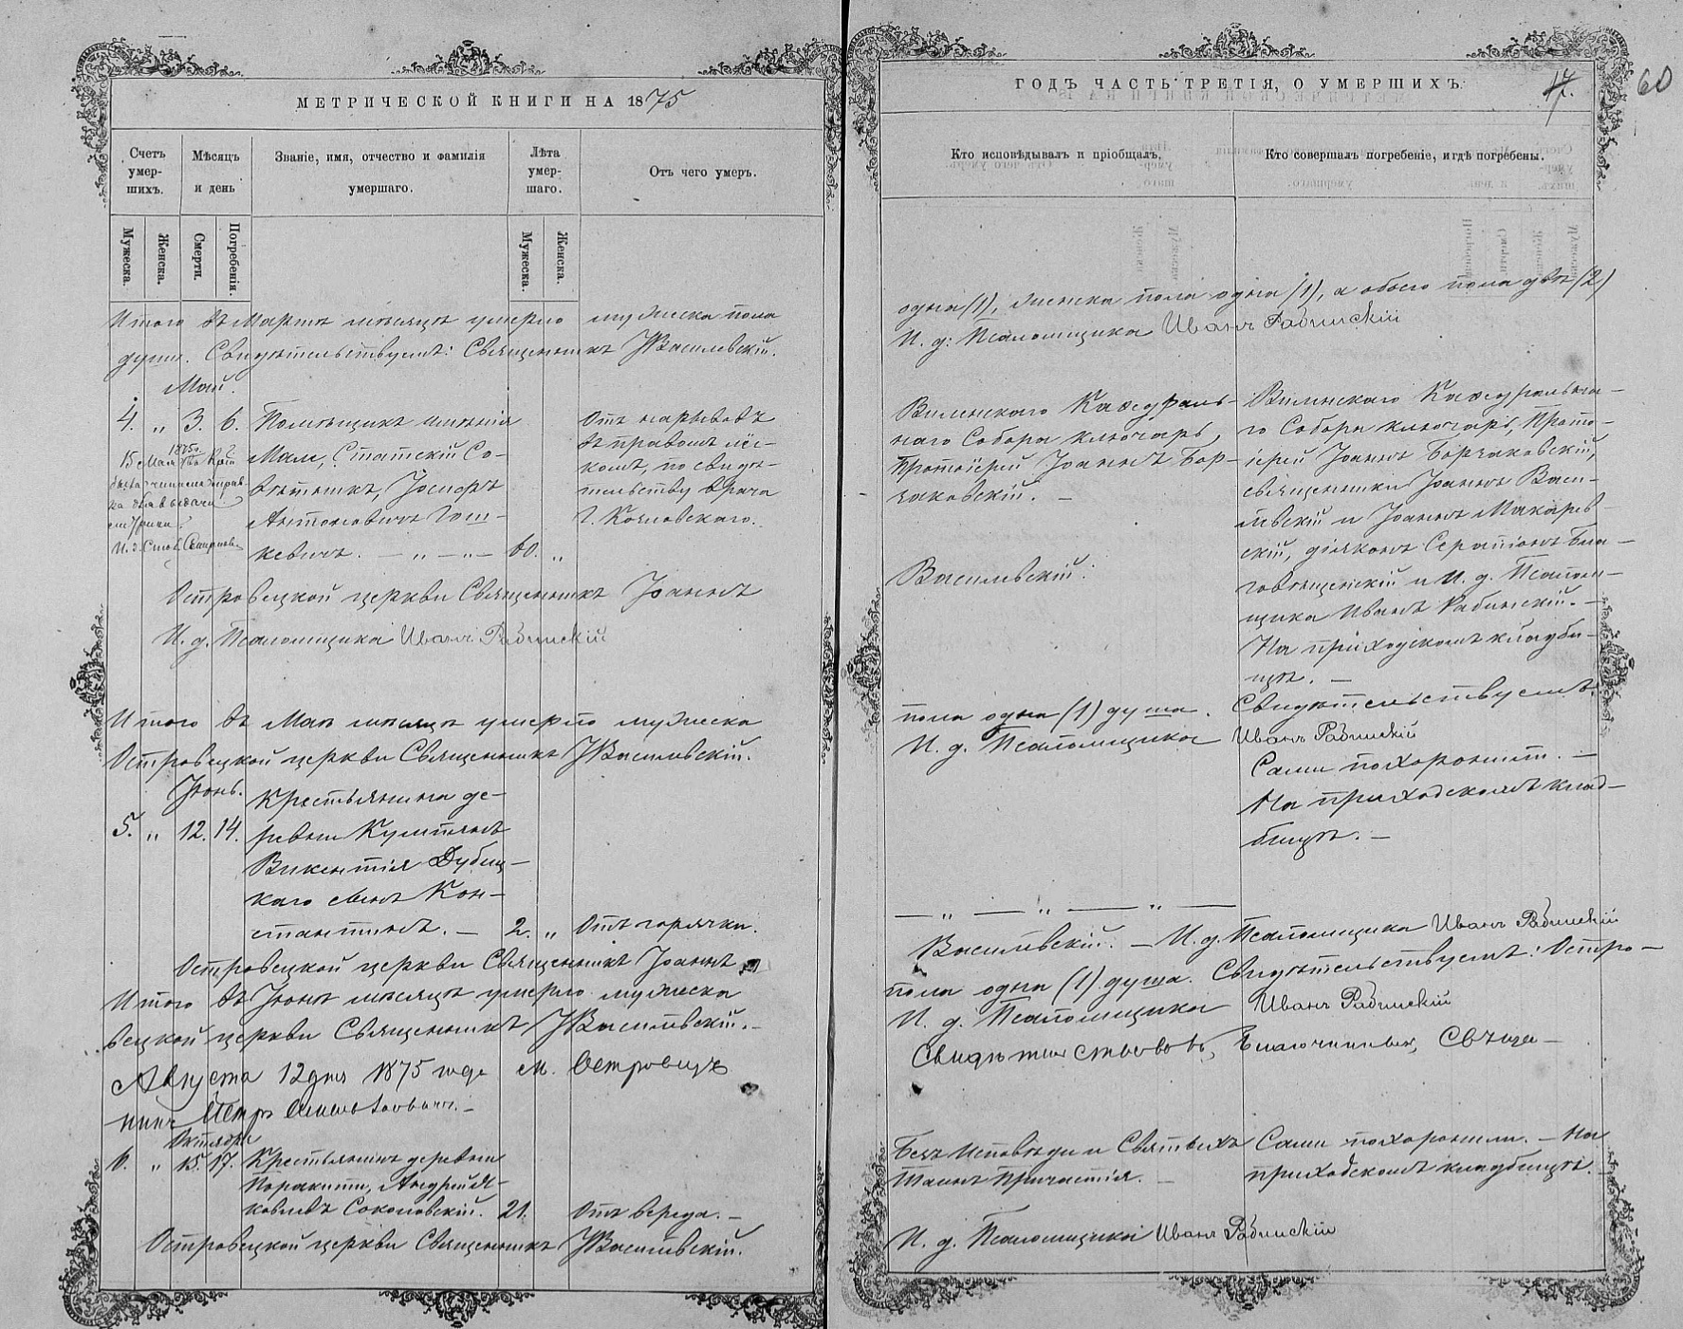
State Historical Archive of Lithuania. F. 605.Vop. 20. Spr. 484. a.59adv– - 60

